Homelessness Identity in Jimmy Santiago Baca's poetry:
A Textual Analysis Study
Submitted By:
Doaa Wagdy Abd El Fatah Mohamed Ashour
To
The Department of English, Faculty of Arts, Benha University
In Fulfillment of the Requirements for M.A. Thesis in English Literature

Abstract
This thesis tries to prove that identity is not an accomplished fact. It is an ever developing and evolving concept. The thesis begins with the construction of the varied and interacted definitions of identity. Then it portrays the identity of immigrants in the United States of America specially Mexican immigrants through their cultural encounter with the new society. It gives a brief history of them and highlights the factors that force them to leave their homes to inhabit new society. The thesis attempts to answer these questions: Are Mexicans considered as a minority or not? How do they perceive themselves and the others? It is an attempt to give a new interpretation to one of the most famous Mexican immigrant poets, Jimmy Santiago Baca. The thesis portrays the journey that Baca, as an ex prisoner, makes until he finds the answers about himself and the others. In his poetic volumes, he raises many questions such as: how Mexican identity is formulated and where do they belong? Are they Mexicans, Americans, in between or both? He does not only try to remind Mexicans about their original identities and how they become different when they immigrated to a different society like the United States of America, but he also tries to help the new generations who grow up in this different country to understand who they really are. Thus, a generation becomes unconsciously trapped between two different cultures with two different motherlands.

Key Words: Homelessness- Home- Diaspora- Exile- Alienation- Identity- Social Identity Theory- Cultural Identity Theory- Jimmy Santiago Baca- Chicano Literature.

Acknowledgments
I would like to express my deepest gratitude to my dear professors for their invaluable help and support.
First, I feel very fortunate to have benefited from the advice and encouragement of my god father Prof. Abu Arab who proved that one can be a poet, a scholar and a gracious teacher as well. His comments on the early stages of this study were invaluable to me. He consistently allowed this paper to be my own work, but steered me in the right direction whenever he thought I needed it.
Then, I cannot say enough to thank Prof. Iman Adawy for her guidance and support. I am gratefully indebted for her valued supervision and comments. Finally, I must express my very profound gratitude to my family for their love and support throughout writing this thesis, and last but not least, my sweet daughter, Habiba , for her continuous encouragement and warmth. Thank you.

The contents
The Title…………………………………………………………………….…...Page number
Abstract………………………………………………………………………....I
Acknowledgment ………………….…...………………………………………II
Some quotations …………..…………..………………………………….……VI
Introduction …………………………………………………………….………V
Chapter One: Homelessness Identity and Its Varied Definitions……………....1
Chapter Two: The Theme of Homelessness Identity in Baca's Poetry…….......44
Chapter Three: The Technique of Homelessness Identity in Baca's poetry……74
Conclusion .........................................................…………………………….....98
Bibliography…………..……………………………………………………....112

Home is the sanctuary where the healing is. . . . Nothing brings as quickly to mind the horror of natural upheaval, civil strife or war as the picture of the "homeless." The deprivation of the security of home is the worst of the mass tragedies.
-WALTER CRONKITE1
These causes have roots at the very core of our American life, in our industrial system, in education . .. in family relations, in the problems of racial and immigration adjustment, and in the opportunity offered or denied by society. . . .
-NELS ANDERSON2
The homeless are homeless, you might say, by choice.
-RONALD REAGAN3

Introduction
At first glance, homelessness' definition could appear as an easy task; however, this is not true. Homelessness, as a social problem, becomes the focus of attention in every sector of society. It tries to prevent the growth of this problem for what was viewed as a temporary crisis. It is also related to the economic section. Eventually, the idea of homelessness as a concept has come to the fore in humanities. This concept, homelessness, is compared with the concept of home. According to Collins English Dictionary home is" the place where one lives, as a birthplace, a residence during one’s early years, or a place dear to one".(701). Thus, "home is the place that protects people from the troubles and conflicts in the outside world" (Choi1). For others like Anzaldua, "home is not so much a physical place as a psychological state, she describes herself as a turtle who carries home on her back" (43). Whether it is physical or psychological term, home is integrated the place where we inhabit and the dream that exists in our minds.
Homelessness, like the term home, is an ideological term, it is generally linked to "the underprivileged or the outcasts who are oppressed or alienated from the normative home" (Choi 2). In Collins English dictionary, "Homeless people have nowhere to live"(703). Terms such as homelessness, Diaspora, exile and alienation are currently used as synonyms to each other, but it is not a scientific method. The thesis will try to prove that they are different in meaning. For example Diaspora is a religious term related to Jews. Diaspora as a term is related to force immigration while homelessness denotes a chosen decision to leave home and go to other country for many reasons such as political, economical and social reasons. The thesis examines the idea of homelessness identity in Mexican ex-prisoner Jimmy Santiago Baca's poetry.
The comprehensive study of the varied definitions of identity from social and cultural perspectives must precede the analysis of the idea of homelessness in Baca's poetry. This way of illustrating helps the reader to understand the great conflicts that happen inside the immigrants. The conflicts are between their original cultural and social heritage and the other cultural and social heritage of the host country that they immigrate to.
Twentieth and twentieth first centuries are characterized by the continual changes and borders have become mixed. Since 1802, the government passed Act that invited people to come there and become citizens because they need more people to build and develop it. People from all over the world come to America, hoping to live a better life because it is the land of hope and dreams that everybody is welcomed to live there and be its citizen. Due to this act, many different immigrants from every corner in the world of different continent, culture, ethnicity and religion come to America (Syamsi 1). This results in indigenous people of the continent, replaced by people from Europe who, felt that they are the real Americans with their cultural heritage that makes them differ from others (2). This is the seed that makes them feel more superior to who is not American. Huntington emphasizes this in his article "The Hispanic Challenge" "America was created by seventeenth and eighteenth century settlers who were overwhelmingly white, British, and Protestant. They initially defined America in terms of race, ethnicity, culture, and religion" (1). In the last decades of the 20th century, the most serious challenge to America's traditional identity comes from the expanding number of immigration from Latin America, especially from Mexico, with dual nationalities and dual loyalties. "One of the largest flows of international migrants whether it is measured in absolute numbers, as a percent of the population of the sending country, or as a percent of the population of the receiving country is the flow of Mexican-born persons to the United States" (Borjas 1).
In order to understand the core of literature of Latinos/ Hispanics in the United States, it is important to trace their historical context. Mexican immigration to the United States can be dated back to the annexation of the territories which is comprised of the north of Mexico as a result of the Mexican-American war that took place from 1846 to 1848. However, the most significant migratory flow, as documented by different studies, is related to the job market generated by agriculture, the construction of railways, and infrastructure projects in the American southwest (Grenville 679-706). The American's idea of immigration shapes an image in the mind that to immigrate to the United States one should travel several thousand miles across the ocean ;however, it is not the case with Mexican immigration. "They come across a 2,000 mile border historically marked simply by a line in the ground and a shallow river" (Huntington 2-3).
Mexicans immigrants constituted 35 percent of the total foreign born U.S population in 2011. The next largest contingents, Chinese and Filipinos, amounted to only 4.9 percent and 4.3 percent of the population (Huntington3).Hispanics totaled according to National Academic press, about one half of all migrants entering the continental United States. Hispanic composed 16 percent of the total U.S population in 2010.
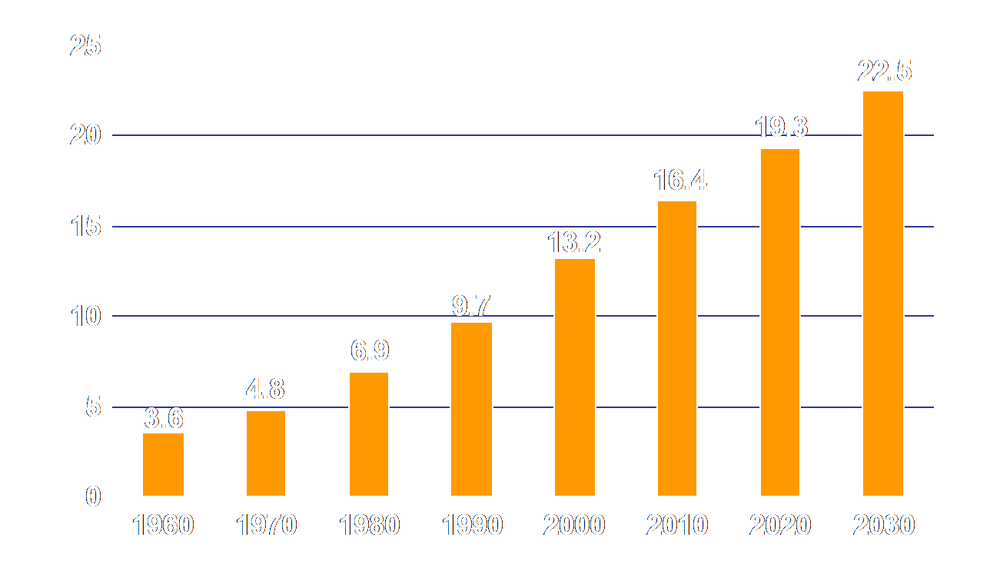
Fig.1 Percent Hispanic of U.S. Population, 1960-2030.
There are differences in meaning between the two terms, Latino and Hispanic. Zimmerman claims that the word Latino refers to “people of Ibero- American birth or family origin who have been born in or who have willingly come to see the U.S as their home” (3). According to A Dictionary of Mexican literature the word Latino is semantically defined as
“Latino/Latina is anyone, regardless of race or nationality, whose language and culture is mainly from the Latin world. The Latin world is composed of the Latin-European countries and the places around the globe that they colonized and left a really strong mark” (xxvii-xliii introduction).
The term Latino is connected with people who live in America as Latino Americano, (xxvii-xliii ).On the other hand, Hispanic's term is connected with the common dominator of language among communities that might seem common. Gracia illustrates that "there is a relationship between Latinos and Hispanics, Latino make sub-ethnic group within the broader Hispanic ethnic group" (208-10). This means that every Latino is Hispanic, but not vice versa. This is a helpful way to show the cultural dimension identity of the Latino experience.
The birth of the Hispanic people occurred with the encounter of Spain with the Indigenous inhabitants of the New World in 1942, as it is described in Elements for a Mexican American Mestizo Christology” a “mestizaje” as "the process through which two totally different peoples mix biologically and culturally so that a new person begins to emerge: Iberians and Indians gave birth to the Mexican and Latin American people" (Elizando 99). In other words mestizo means the mixed people who live today in Mexico, Central America, South America. In “Is Latina/o Identity a racial identity?” Alcoff concludes, from a political perspective, that Latino is more preferable than the term Hispanic. She believes that the concept of Mestizo comes to be applied to Latinos in America as a label for Latinos whose “descendants are entirely African, Indian, or Asian, mestizo becomes the cornerstone of the culture” (42). The growing numbers of Mexican who migrates to the US have an impact on the communities receiving them. The first issue is the provision of housing, healthcare, and education for the newcomers (McConnell 767). The second issue is the challenge of identity is extended along generational lines. the children as their parents have to struggle with their values of the new culture and racism On the one hand School not only segregate the children, but it also helps keeping the Mexican American children on the margins of the society as it pushes youths out of school at an early age in order to secure the advantage of cheap labor by teachers who function as guide to those students by teaching them the virtues of the capitalism and Mexican culture is not equal to American culture at the same time Mexicans find themselves are labeled as threaten to public health and criminals (Chavez 43).
In “Hispanic / Latino Identity labels: An Examination of Cultural Values and Personal Experiences” it is shown that because of the great poverty in Hispanic community people begin to look for jobs that have a direct effect on Mexican women who desire to bring their children so they become the proper labor force for transitional industry. At the same time this evokes another situation which is concentrated on the migration of men who come to U.S for Jobs leaving their families behind at the same time the mother is burdened with the full responsibility towards her family, which leads to establish a two-family situations; a wife across the border and a second wife in the U.S (148)

The result of the great size of Hispanic immigrants in the United Stated is the use of Spanish through successive generations "more than 28 million people in the United States spoke Spanish at home, 10.5 percent of all people over age five, and almost 13.8 million of these spoke English worse than who spoke English very well" (Hintington5). Pew Hispanic Center publishes in 2011 A Demographic Portrait of Spanish Speaking Population in Central and South America.

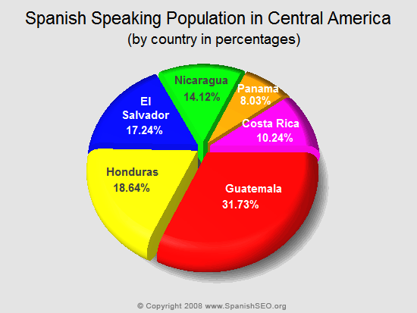

Fig.2.
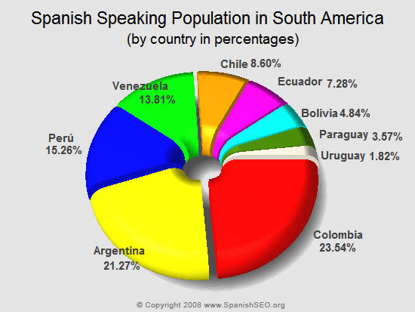

Fig.3.
Spanglish is a language that results from the interaction between Spanish and English. It is used by people who speak either both languages, or parts of both languages, mainly in the United States. It is a blend of Spanish and English lexical items and grammar. Spanglish does not have one unified dialect as the varieties of Spanglish spoken in New York, Florida, Texas, and California differ. Spanglish is so popular in many Spanish-speaking communities in the United States, especially in the Miami Hispanic community, that monolingual speakers of standard Spanish may have difficulty in understanding it (Martinez 124-29). For many, Spanglish serves as a basis for self-identity, because it reflects how many American minority-feel towards their heritage(Rothman 515). In “Language as a Representation of Mexican American Identity” Faught correlates between the varieties of Mexican communities and their linguistic varieties that play fundamental role for expressing their ethnic identities (44). Mexican Americans use Chicano English Language (CHE) and they use a code switching “Spanglish” that play an important role in construction their ethnic identity (Faught 44-46).
Examples:
Spanglish | English basis and meaning | Standard Spanish | Meaning of Spanglish word in standard Spanish
Actualmente | actually | enrealidad | currently
Aplicación | application (written request) | solicitud | application (of paint, etc.)
Bizarre | bizarre | estrambótico | valiant, dashing
Carpeta | carpet | alfombra, moqueta | folder
chequear/checar | to check (verify) | comprobar, verificar | —
Librería | library | biblioteca | bookstore
Mapear | to mop | trapear | to map (rare)
Parquear | to park | estacionar, aparcar | —
Rentar | to rent | alquilar | to yield, to produce a profit
Wacha | to watch out | cuidado | —
Table.1: Rothman, Jason; Amy Beth Rell "A Linguistic Analysis of Spanglish: Relating Language to Identity". Linguistics and the Human Sciences1 (3)2005.
Literature is considered a mirror of society; that is why the Hispanic American literature is a good example of how literature reflects the life of these immigrants. According to Encyclopedia of Hispanic American Literature
“The Hispanic American literature emerged from the Spanish colonial writing of the Americans. Hispanic Literature that has been written in the United States refers to "the literature that is written in English and concerns mainly with the expressing and showing, how is the life in the US. It reflects how Hispanic Americans are viewed either by themselves or by mainstream culture. Hispanic American literature contains within writings from different countries and cultures such as Mexicans Americans writings"(Suarez 31-32). In other words Hispanic American literature is the Immigrants Mexican literature. It is different in its themes than the Latino literature because Hispanic literature concerns about the life of the immigrants in the United States.
An early classic attempt of this type is represented in a novel entitled Pocho that was written in 1959. The novel is about a guy whose parents migrate to the United States from Mexico to make their life better (33). Hispanic American writers believe that "in the lives of their characters Spanish is not a foreign language but rather a vital part of everyday speech" (34). So they resist by using Spanish language the extinct of their culture and at the same time, they protect and preserve their identity by using Hispanic American expressions (34-35). They want to communicate with their deeply rooted traditions and cultures as a way of identifying with their ethnicity. Mexican Americans are different in their writing than Chicano writers because they feel more about national identity with Mexico than Chicanos who are allied with the American culture (33).
Chicano literature takes its shape after the conclusion of the Mexican War in 1848.However, the cultural forces that paved the way to Chicano literature date from the last sixteenth century. It is in the sixteenth century that the Spanish began their exploration of what is now known as the Southern United States (Parades1-2).In a setting where no education, a new literary genres were needed to be widely dispersed such as folktales and legends. Suarez shows that "their literary tradition owed its debt of construction to the corridos that mix Spanish with English to create a language that express the new reality" (32-33). By 1900, Mexican American Literature emerged as a distinctive part of the literary culture of the United States but it remained under the umbrella of Latin American letters and oral tradition (Parades 4). Around the turn of the century, in 1945, Josephina Niggli published her novel Mexican Village that was the first literary work by a Mexican American that was red by American audience (Parades5). It conveyed to the American readers the Mexican American experience through using references to Mexican legends, folktales and proverbs (Parades 5). By the World War II, the movement of Mexican Americans emerged in the large cities where they were badly needed for labors. As a direct result, this reduced the Mexican cultural isolation. It was not surprisingly then that, Rudelfo Anaya's, the best known of Chicano novels, focused on the impact of the World War II on Mexicans in New Mexico (Parades 6).
Chicano writers try to create a new form of literature through amalgamating American literature's writing style and techniques with the Mexican oral tradition of storytelling to establish new notions of their present, and this process between the two cultures constructs the formation of an individual or collective identity (Hall 394). Hall contends in “Old and New Identities, Old and New Ethnics” that identities formation process cannot be looked as a stable fixed process but rather as a process undergoing constant change and reformation. He assures that there are “New and Old identities” formed in the world of globalization (Hall 48).
Among the huge amount of Mexican American writers is Jimmy Santiago Baca. He was born in 1952 in the small rural town of Estancia, Santa Fe, New Mexico. Baca's mother was Chicana and his father was an Apache Indian. His parents divorced when he was two years old. Much of his writing seeks to recover those elements of himself that were lost between the years, following his parents' divorce and his rebirth through language, Between the ages of eleven and twenty, Baca traveled to southeastern States before returning back to the Southwest. When he was twenty, he was charged with drug possession and sentenced to five years at the prison in Florence, Arizona. The sentence was later extended to six years, and he spent four of those years in isolation. There, he learned to read and began writing poetry, producing a journal and several short poems.
With the encouragement of his fellows, he sent several of his pieces to Mother Jones Magazine. He attracted the attention of poetry editor Denise Levertov, who published three of the poems in the periodical. In his collection of essays, Working in the Dark: Reflections of a Poet of the Barrio (1992), Baca recalls that he taught himself to write by phonetically sounding out words from a textbook he had stolen from a prison official. With practice, he eventually developed enough competencies to compose letters and ultimately poems. The difficulties arising from his extremely limited literacy skills were compounded by the daily distractions of bloody fights with other convicts, an alleged contract on his life by the brutal Mexican Mafia prison gang, guard's brutality, and frequent trips to isolation. He also endured a brief stay in the prison's mental ward, during which he was forcefully medicated with powerful mind-numbing psychotropic drugs.
Baca's first collection of verse, Immigrants in Our Own Land, appeared in 1979 at approximately the same time as he was released from prison. Baca published several additional volumes of poetry in the 1980s, including his broadly successful Martín and Meditations on the South Valley. After the publication of this work, Baca's fame as a poet and a spokesperson for Chicano culture rapidly developed. Soon he was lecturing and reading his works extensively across the United States, as well as hosting poetry workshops. By the late 1980s, Baca had lived as a poet in residence at the University of California, Berkeley and Yale University. Mainstream media coverage, the staging of his drama Los Treshijos de Julia (1991), and the production of the film Bound by Honor contributed to his growing celebrity in the Chicano community and on a national scale. From the 1990s up till now, Baca is one of the most extensively read and respected Chicano poets in the United States. He settled with his wife and two sons in the Black Mesa region in New Mexico and continued to write prose and poetry, such as the novel In the Way of the Sun (1997) and the collection Healing Earthquakes: A Love Story in Poems (2001).
Baca’s work is concerned with social justice and revolves around the marginalized and disenfranchised. His works treat themes of addiction, community, and the American Southwest barrios. In an interview with John Keene, Baca says, “I approach language as if it will contain who I am as a person”—a statement that reflects the poet’s interest in the transformative and generative power of language. Immigrants in Our Own Land was Baca’s first significant collection that based on his imprisonment. In the Encyclopedia of American Literature, Catherine Hardy wrote that the poems in the volume: “reveal an honest, passionate voice and powerful imagery full of the dark jewels of the American Southwest landscape (llanos, mesas, and chiles) and the chaotic urban landscape (nightclubs, rusty motors, and bricks) woven into a rich lyricism sprinkled with Spanish.”(410).
Jimmy Santiago Baca has based his poetry on a commitment to the presentation and preservation of a marginalized, degraded, and often silent segment of American society. Speaking about his utilization of Chicano motifs in his work, he has said that one can "be successful in this society and still offer it all the resources that come from [one's] culture." His faith in the latent redemptive energy inherent in the production of poetry, an act he regards as responsible for his own survival. It is an act which he feels can restore dignity to other people, who have struggled with destabilizing psychic states. It has enabled him to explore and express conditions of extreme mental and emotional duress.
His work charts a course from near total despair through periods of reversal and dejection toward a life of real accomplishment in literary and social terms. His semi-autobiographical novel in verse, Martin and Meditations on the South Valley (1987), received the 1988 Before Columbus Foundation’s American Book Award in 1989. In addition to over a dozen books of poetry, he has published memoirs, essays, stories, and a screenplay, Bound by Honor (1993), which was made into a feature-length film directed by Taylor Hackford. Baca’s other poetry titles include Healing Earthquakes (2001), C-Train & 13 Mexicans (2002), Winter Poems Along the Rio Grande (2004), and Spring Poems Along the Rio Grande (2007). In addition to the American Book Award, Baca has received a Pushcart Prize and the Hispanic Heritage Award for Literature. His memoir, A Place to Stand (2001) garnered the International Prize. In 2006, Baca was awarded the Cornelius P. Turner Award, which honors GED graduates who have made “outstanding contributions” in areas such as education, justice, and social welfare.
Baca has conducted writing workshops in prisons, libraries, and universities across the country for more than 30 years. In 2004, he launched Cedar Tree, a literary nonprofit designed to provide writing workshops, training, and outreach programs for at-risk youth, prisoners and ex-prisoners, and disadvantaged communities. Baca holds a BA in English and an honorary PhD in literature from the University of New Mexico. Baca's almost archetypal rise from poverty to prison to literary fame is extraordinary yet not uncommon. Baca underscores his prisoner author genealogy in his collection of essays, Working in the Dark, in which he states:"I was born a poet one noon, gazing at weeds and creosoted grass at the base of a telephone pole outside my grilled cell window. The words I wrote then sailed me out of myself, and I was transported and metamorphosed into the images they made Writing bridged my divided life of prisoner and free man" (11).
Baca's Major Works
The poetry of Immigrants in Our Own Land, in 1979 Baca's first significant collection, is largely focused on his experiences in an Arizona prison. Detailing personal torment, thoughts on injustice and oppression, and his feelings of camaraderie with his fellow inmates, Immigrants in Our Own Land outlines a vision of hope and faith amid suffering. In addition to its title poem, which alludes to the impression shared by many Chicanos of being aliens in the southwestern United States despite their long history there, the collection also includes the powerful “So Mexicans are Taking Jobs from Americans,” one of Baca's more political pieces. "What's Happening" (1982) also largely deals with Baca's prison experience, while additionally depicting the poet's attempts to reestablish his identity after incarceration, both in personal, psychological terms, and in relation to the wider community. Martín and Meditations on the South Valley (1987) represents a considerable development in Baca's poetic works. It takes the form of two complementary, semi-autobiographical narrative poems that detail in near-mythic terms the world of a poor, disestablished Chicano youth, Martín, as he grows up on the streets and wanders through the American Southwest in search of identity, meaning, and stability. Eventually finding what he is looking for in Gabriela, Martín makes a home for himself, starts a family, and reconnects with his Chicano roots.
Baca incorporated an earlier collection of lyrical works, Poems Taken from My Yard (1986) into Black Mesa Poems (1989), in which he once again evokes the working-class world of the barrio and emphasizes themes of regeneration and reconciliation brought about by a renewed connection with community, history, Chicano culture, and the landscape of the American Southwest. Among Baca's other works, his chapbook entitled simply Jimmy Santiago Baca (1978) contains several short poems and a prison journal, while the essays and autobiographical stories of Working in the Dark: Reflections of a Poet of the Barrio (1992) reveal his frequently expressed love of language and thoughts on the process of poetic composition.
Baca's Principal Works
Jimmy Santiago Baca (novella) (1978)
Immigrants In Our Own Land (1979)
Swords of Darkness (1981)
What's Happening (1982)
Poems Taken from My Yard (1986)
Martín and Meditations on the South Valley (1987)
Black Mesa Poems (1989)
Los Treshijos de Julia (play) (1991)
Working in the Dark: Reflections of a Poet of the Barrio (essays and short stories) (1992)
Bound by Honor [also known as Blood In… Blood Out (screenplay) (1993)
In the Way of the Sun (novel) (1997)
Set This Book on Fire(1999)
Healing Earthquakes: A Love Story in Poems(2001)
A Place to Stand: The Making of a Poet (memoir) (2001)
The thesis examines two main issues. The first is the use of the term homelessness not the other terms that the other researchers get used to use such as Diaspora term, the alienation term and, the exile term because these terms are different from the term homelessness. The second issue examines the idea of homelessness identity in Baca’s poetry and how this idea is developed through the whole life of Baca and by extension through his volumes. Homelessness to Baca is emphasized when he goes to the United States was. He imagines that he finally finds a place where he can stand. But he finds injustice society that looks at him as an illiterate Latino man. In his memoir a place to stand he shows how he was jailed because he didn’t understand what the judge told him, he was accused with a crime he didn’t do it only because he couldn’t speak English well (77-88).
This thesis proves that throughout Baca's poetic volumes homelessness is not an individual feeling but also an entire injustice system .For example in his memoir, A Place to Stand, where he yearns to be accepted by his family, friends and the external society, “the sad fact was that there was nothing to keep me in no society- no family, no friends, nothing at all. I was utterly alone"(88). Baca states that he was thirteen years old when he landed “behind bars for the first time, in a detention center for boys” (Michelson 20). Baca's writings are home for him. That brown illiteracy man who was abandoned by his family, that scary child who was afraid to go to school because he couldn’t understand his friends so he was homelessness. That homeless child finally finds a place to stand, a place to face the world and says I still exist. From hate reading to compose compassion poems, that is the journey that Baca takes. He walks out from prison as a self-identified Chicano poet.
Aim of the Thesis:
The thesis has two main aims. The first is to shed the light on Jimmy Santiago Baca, as one of the most famous Mexican American poets, and map out his biography to explore his identification with Hispanic literature. The second is to show the impact of the concept of homelessness identity on his poetry and how it has become functional in stressing his belief that poetry is the ultimate act of self-creation. The thesis is divided to:
Introduction:
The introduction traces Baca's biography. It also explains the definition of "Hispanic literature" and provides a literature review of the work which has been conducted on Baca to set for the novelty of the idea of homelessness in his poetry.
Chapter One:
Chapter one discusses the identity theory, social identity theory and cultural identity theory and how they are amalgamated with each other. It also discusses the definitions of the terms diaspora, alienation, exile and, homelessness identity and its varied definitions.
Chapter Two:
Chapter two explains and traces the theme of homelessness identity in Baca's poetry. It stresses the development of this theme in his poetry throughout his poetic oeuvre.
Chapter Three:
Chapter three discusses the technique that Baca uses as a means to emphasize the concept of homelessness identity in his poetry.
Conclusion:
The conclusion is an assessment of the main argument propounded in the study and the findings arrived at.

It refers to the Europe people specially from Britain
When Mexicans migrated to US, they used English marked by sounds and grammar from their native language (Faught 46).
It is a complicated intermingling of Spanish and English (Faught 45).
Chicano literature is the literature written by Mexican Americans in the United States. Although its origins can be traced back to the sixteenth century, the bulk of Chicano literature dates from after 1848, when the USA annexed large parts of what had been Mexico in the wake of the Mexican-American War. Today, it is a vibrant and diverse set of narratives, prompting (in the words of critics) "a new awareness of the historical and cultural independence of both northern and southern American hemispheres
It is a Spanish verb means to run. They are the popular ballads of the mid 19th century that recounted heroic exploits and also connected with Chicano poetry in 20th century, laying the foundation for a poetics that fuses the oral, written, music, and word (Saurez 33). It focused on epic and symbolic events.

